BUSINESS ETHICS & SUSTAINABILITY

How Ethical is Anonymised Company?

6
th

January 2017

Emma Gaskill

University of Salford

Table of Contents
Introduction 2
Section A: How Ethical Is Anonymised Company 2
Fairtrade 4
Lower Carbon Footprint 4
Socially Responsible 5
Findings and Considerations: 5
Section B: United Nations Sustainable Development Goals 6
Goal 2: Zero Hunger 7
Goal: 14: Life below water 7
Recommendations: 8
Conclusion 9
References 10

Abstract

In order for organisations to remain sustainable in a forever changing climate, managing the triple bottom line is imperative (Edwards & Orr, 2005). Anonymised Company are a well know retailer which serves over 34 million customers through its 914 stores and ecommerce platform. Founded in 1884, the organisation has grown dramatically from a single market stall, to a multi-functional, international business. The growth trajectory of the organisation is based on its approach towards business ethics and sustainability. The aim of this report is to assess the effectiveness of Anonymised Company when dealing with sustainability issues and make recommendations where required. There are 17 sustainable development goals which have been set by the United Nations, all with different aims. As part of company strategy, Anonymised Company work towards many, if not all of the goals, but there is a clear focus on goals 2 and 14. By continuing to implementthis strategy, (by 2020) the organisation will have further strengthened its ethical values on a global scale and could see their positon on the most admired list improve once again and who knows maybe the top spot could be theirs once more.

Introduction

“The greatest threat to our planet, is the belief that someone else will save it” (Swan and Reavill, 2011, p. 256). In order for organisations to remain sustainable in a forever changing climate, managing the triple bottom line is imperative (Edwards & Orr, 2005). In 2015, as part of an action plan by The United Nations to transform the world, 17 sustainable development goals with 169 targets were announced. These goals have been adopted by many organisations around the world and their aim is to transform the world by 2030. For this report the researcher will be analysing Anonymised Company.

Anonymised Company are a well know retailer which serves over 34 million customers through its 914 stores and ecommerce platform. Founded in 1884, the organisation has grown dramatically from a single market stall, to a multi-functional, international business. The growth trajectory of the organisation is based on its approach towards business ethics and sustainability. The aim of this report is to assess the effectiveness of Anonymised Company when dealing with sustainability issues and make recommendations where required.

Business Ethics is often described as behaviour or decisions made within an organisations key values (Ferrell, Fraedrich, & Ferrell, 2014) and the study of situations which arise within business where concerns of right and wrong are addressed (Crane & Matten, 2010). Developing countries can provide many opportunities for multinational companies in terms of low cost labour and natural resources, however, there are many challenges which can be faced when dealing with developing countries, therefore, extreme care must be taken to avoid encountering these issues.

In part A of this report the business ethics of Anonymised Company will be critically assessed using two conceptual/theoretical perspectives; global ethics and Chris Arnold - The Ethical Sphere, 2009. In part B the researcher will focus on two of the sustainable development goals, zero hunger and life below water.

Section A: How Ethical Is Anonymised Company?

In 2015 Anonymised Company were ranked 133rd on Britain’s Most Admired Company List, however, this is a huge decline when compared to 81st in 2014 and the top spot (first) back in 2007. So what does this mean for the organisation and does this really have any effect on its ethical values and position within the global market.

The need to observe ethical business practices is embodied in the organisational goals that outline a platform for growth based on their eco plan (Anonymised Company, 2016). This includes a focus on global ethics, which ratifies the organisations place within the international business environment and their commitment towards observing standardised ethical practices. Beavis (2012), suggested that Anonymised Company has taken its work on ethical trading to a whole new level and with suppliers in over 70 countries, the sustainability of the organisation depends heavily on its supply chain.

According to Kaye (2014), Anonymised Company have been one of the world’s most socially responsible and sustainable retailers since they launch Plan A in 2007. Eco-plan forms part of the organisations code of conduct and some key ethical values contained within this document focus on environmental protection, responsible sourcing and fair trade principles. These clearly link within some of the aspects of the Ethical Sphere Model shown below, these also link with global leadership and the requirement for the organisation to be globally ethical. In addition, under Anonymised Company environmental plans, there is a commitment towards sustainable development and business planning.

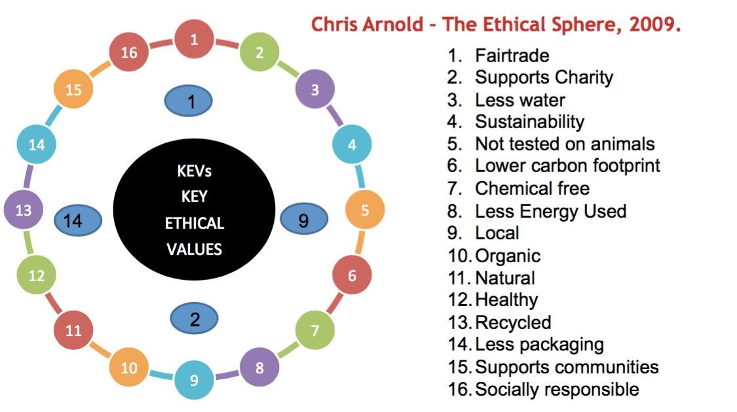
Figure 1: The Ethical Sphere (Source: eu.wiley.com, 2009)
Fairtrade

The concept of fair-trade pricing is typically thought of as a mutual agreement by the buyer and seller (in developing countries) under competitive conditions (Crane & Mattern, 2010). In 2006, Anonymised Company boosted its global ethical image when it first launched its commitment to fair-trade (Blowfield, 2012) with its “look behind the label campaign” (Milmo, 2016) and in 2010, they became the first certified retailer to stock fair-trade certified vegetables, launching this new range with green beans from Kenya (Smithers, 2010). Following this range, the ethical image was boosted further when they introduced the first of its fair-trade clothing range with t-shirts and socks, with these being cut from a more conscientious cloth which contained less chemicals and salt (Milmo, 2006).

On the surface, the commitment of Anonymised Company to increase its fair-trade products with a clothing range appears to be viable, however, there are constraints with fair-trade supplies, such as cotton which is supplied by farmers in Gujerat, India. Due the limited stock of cotton which is available, it is unlikely that all of Anonymised Company clothing range could become fair-trade (Diet & Ethos, 2016). It has also been noted that when looking at fair-trade foods, the constant demands for lower prices saw a decline in pay and working conditions for workers on banana farms in Costa Rica in 2007, however, these have started to improve over the last few years.

Lower Carbon Footprint

Advances in technology are steering organisations towards sustainable consumption and becoming ‘Carbon neutral’ is the aim of many organisations (Berry, 2007). Carbon neutral status can be achieved when an organisation has zero net carbon emissions and in 2012, Anonymised Company alleged to be the first retailer to achieve this status (Nicholls, 2012). In 2013, the organisation joined forces with UNICEF to promote their carbon offset project. The first aim of this project was to improve the lives of Children in Bangladesh whilst cutting carbon emissions, which are the main cause of climate change (Partners, 2016). By working with UNICEF, Anonymised Company are able to promote their ethical values on a global scale.

There is no doubt that Anonymised Company have set various initiatives in order to reduce its carbon footprint, both within the UK and globally. There are however issues that the organisation may face, as the nature of addressing the worlds sustainability, along with its carbon footprint issues, is not guaranteed and may increase business risk (Blowfield, 2012). According to Greenpeace, even if Britain was to reduce its carbon footprint by 34% by 2020, there is still a great deal which needs to be done before worldwide impacts can be made (Stop climate change, 2016). This being said, if organisations start to take responsibility for their carbon footprint, by making small changes, one step at a time, the world could become a more sustainable place and ultimately, climate change could start to be improved.

Socially Responsible

Social responsibility can be defined as ‘an organisations obligation to maximise its positive impact on stakeholders and minimise its negative impact” (Ferrell, Fraedrich, & Ferrell, 2014, p. 11). Anonymised Company have a positive reputation for being socially responsible and according to Beavis (2012), by doing the right thing they are leading change for the better. Eco-plan clearly shows it makes business sense as in 2010/11 it returned 70 million GBP in profits. These profits were ploughed back into its sustainability work and by working with various countries such as Kenya (sustainable water use), Turkey and China (setting up eco-factories) and Bangladesh (fair pay standards), the organisation is considering its social responsibility on a global scale, clearing displaying a global ethical approach.

Nevertheless, the social responsibility of Anonymised Company came under fire in 2013 when they were accused of using tactics similar to Amazon in order to avoid paying tax (Ball, 2013). Anonymised Company denied these claims stating that the transactions in question were authorised by their offices in Ireland, therefore, the reduction in tax charges were legitimate. This response by may be true, however, tax avoidance is a serious offence and one that could seriously damage the reputation of the organisation leading to a reduction in sales and ultimately decreasing its profit margin. The organisation also came under fire in October 2016 when it was revealed that child refugees in turkey were making clothes for the store in poor working conditions. The organisation denied these claims advising that all their suppliers must adhere to its Global Sourcing Principals, however, as a responsible business, more must be done to ensure that their suppliers adhere to the set guidelines. Both of these issues could have serious negative impacts on its stakeholders, which goes completely against social responsibility.

Findings and Considerations:

Every country has its own ethical views and values and although Anonymised Company work closely with many organisations such as UNICEF and WWF and their aim is to improve ethics and sustainability around the world, they have no specific code of ethics when dealing with global organisations. This could suggest that they adopt an ethnocentric approach, where they use their home ethical approaches and adopt them around the world, this could be a positive approach for Anonymised Company but they could also be faced with some criticism for not adopting the ethical values of the country in which they are trading.

The are many positive aspects surrounding Anonymised Company, which are all displayed on the organisations website, with many articles concurring these points, however, when looking in depth at the organisation, there are no accreditations or awards displayed on the website. This could raise a question as to the reliability of these articles, as well as the true ethical status of the organisation as it could be argued that in order to prove the validity of an organisations claims, then external accreditation is essential.

Section B: United Nations Sustainable Development Goals

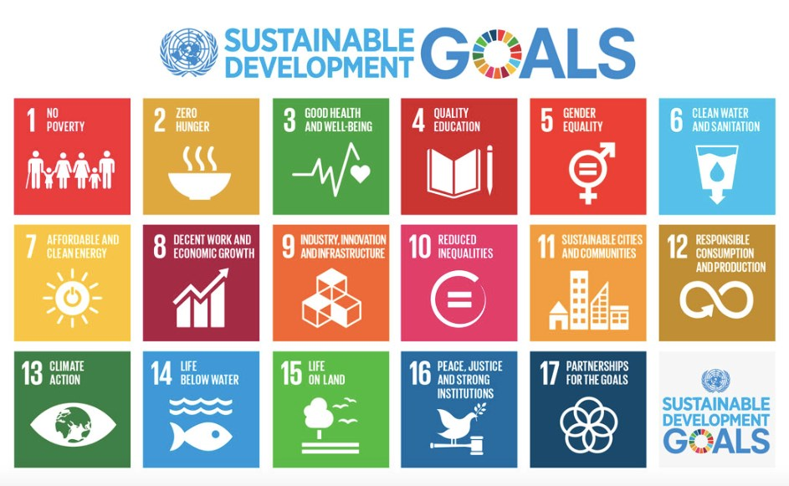
Figure 2: Sustainable Development Goals (Source: UN.Org, 2016)

There are 17 sustainable development goals which have been set by the United Nations, all with different aims. As part of Eco-plan, Anonymised Company work towards many, if not all of the goals, but there is a clear focus on goals 2 and 14.

Goal 2: Zero Hunger

In order to support the zero hunger sustainable development goal, Anonymised Company have implemented a number of tools in order to assist them with achieving its required aims and objectives. In 2016 they teamed up with Morrison’s and Waitrose to support The Grocers waste not - want not campaign (Tatum, 2016). This campaign aims to cut the amount of food wasted in the grocery supply chain and distribute it to those who need it.

This partnership was formed following a report that Anonymised Company had reduced food waste by 9% over the last 3 years (Robertson, 2016). On the face of it, this is a great achievement, nevertheless, they are still producing 3.84 tonnes of waste per year, which is a phenomenal amount and covers 1,000sq ft. They do however, plan to have reduced this waste further to 20% by 2020.
Another tool which is being utilised by Anonymised Company, along with Greggs (Bakers) is the use of a solidarity fridge (Hall, 2016). This project has been set up in Somerset by the towns resilience officer, Anna Francis and between the hours of 8am and 8pm, businesses and individuals can deposit food which would otherwise be destined for the bin. Although this is a positive tool to be using, it is restricted to one town in Somerset and greater achievements could be accomplished if this type of project was adopted throughout other cities.

Even though Anonymised Company are implementing a number of positive tools, they are still facing criticism for its food waste. In November 2015, staff at its Bradford store were caught throwing away trolley loads of food (Sheffield, 2015), when questioned about this, the response that was given was, as this was a new store, to gauge consumer buying habits, reducing food prices was not an option and therefore there was no option but to throw this food away. The store also advised that they were in the process of linking with a charity in order to combat this issue in the future (Sheffield, 2015).

Goal: 14: Life below water

By working with the WWF, Anonymised Company is showing its commitment to sustainable fishing, this also supports the sustainable development goal; life below water. By working together, the organisations are aiming to tackle various issues such as overfishing, bycatching and discards (Smithers, 2010). There have been many issues surrounding Europe’s depleted fish stocks and positive steps needed to be taken in order to advance sustainable fishing and increase fish stocks.

In line with this partnership, in April 2016, Anonymised Company announced that it was making a global commitment to ensure that any fishing boats supplying the company meet the demanding environmental and welfare standards and that all boats will be certified by the Responsible Fishing Scheme by 2021. The organisation is also urging other seafood suppliers to sign up to the responsible fishing scheme. The scheme has been developed in order to raise fishing standards, allowing those in the supply chain to demonstrate their commitment to the responsible sourcing of seafood. The responsible fishing scheme is the only global standard that audits compliance on fishing vessels which includes ethical standards and welfare.

Working directly with organisations to improve sustainable fishing will no doubt improve life below water, however, this alone isn’t sufficient and Anonymised Company needs to be doing more. Microbeads found within some of the Company’s exfoliating beauty products are too small to be filtered out during sewage and are not biodegradable, they are becoming a direct source of pollution and ultimately effecting the food chain (Derbyshire & Sean Poulter Consumer Affairs Editor, 2016). This is a major concern and as a responsible supplier Anonymised Company should have considered the possible impact of all its ingredients prior to production.

Cosmetics Europe has recommended that organisations stop using these microbeads and Anonymised Company are planning to remove them from their products by 2017. This is clear evidence that the Company is ‘greenwashing’, they are advertising that they are working with various organisations to improve sustainable fishing when in fact, they are producing products which are damaging the seafood to which they are claiming to be protecting.

Recommendations:

It is important for sustainability that every organisation does its utmost to adhere to the sustainable development goals and although there are many positive aspects within what has been achieved by Anonymised Company it has been noted that there is still a lot of room for improvement.

The plan by Anonymised Company is to have reduced food waste by 20% by 2020, although this plan appears to be going in the right direction, tonnes of food will still be wasted every year and alternative options need to be considered. By working with more charities, the organisation could decrease the wastage further and by exploring the option of turning some waste products into organic fertilisers, this would not only decrease food waste further but by using pesticide free fertiliser farmers would also be working towards a more sustainable planet.

As a responsible supplier, Anonymised Company must take action immediately to remove the microbeads from their products, by stating that they will be removed by 2017 just isn’t good enough. There are many alternatives which could be used by the organisation such as ground almonds, jojoba beads and even sugar, all these products are natural and safe for the environment, whilst still providing effective exfoliation (“Natural Exfoliants: Alternatives to
Microbeads,” 2015).

Conclusion

Many organisations are having a detrimental impact on sustainability and to help combat these issues clear sustainable business visions are now becoming an essential characteristic for corporate survival (Blowfield, 2012). This report has critically assessed the business ethics of Anonymised Company using aspects from within Chris Arnolds Ethical Sphere and global ethics. Although it is clear that by implementing Eco-plan, Anonymised Company are making a major environmental step forward, this policy and its approach to ethical trading within the supply chain is voluntary, therefore the organisation could come up against some resistance from suppliers which would need to be addressed accordingly.

This report has also evaluated how the organisation has implemented two of the sustainable development goals; zero hunger and life below water, and whilst it was noted that the organisation is working closely with organisations to improve food waste and sustainable fishing, there are areas which still require consideration and improvement. Taking all these points into consideration, the question could be raised as to whether a supermarket the size of Anonymised Company can ever truly be ‘green’.

Overall, the fact that Anonymised Company is currently sitting at position 133 on Britain’s Most Admired Company list bears no reflection on the ethical values of the organisation or its position within the global market. By continuing to implement Eco-plan, (by 2020) the organisation will have further strengthened its ethical values on a global scale and could see their positon on the most admired list improve once again and who knows maybe the top spot could be theirs once more.

Appendix

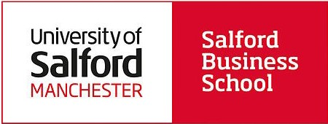

1

Business Ethics
and Sustainability
2016/17
Module Coursebook

  - Individual Written Assignment (60%) and Marking Criteria

As an individual, select a single company from the Britain’s Most Admired List 2015. (or see Appen- dix 1). Please note you will be asked to select this company in your seminar in week 4. Companies are not permitted to be selected by more than one student. By week 4 you should have explored and investigated the company of your choice (and at least one back up company).
When your company has been confirmed by your seminar tutor please answer the following assign- ment question:
    - Critically assess the company from the perspective(s) of business ethics or corpo- rate social responsibility (CSR) using two contrasting conceptual or theoretical ap- proaches.
    - Select two of the Unit ed Nat i ons Sust ai na-
ble Development G oal s (SDGs) and evalu- ate how the organisation is implementing these practices. Provide recommendations on how the company could improve further in these areas
Please ensure you have an introduction, then 2 sections (A and B) and a conclusion.
The range of material you analyse could include information provided by the corporation (e.g. sus- tainability / social / CSR policies and reports) as well as information about the corporation e.g. sto- ries in the media, including specific incidents (scenarios) the corporation has been involved in.

However, you must conduct your own analysis of the material. The detailed report guidelines will be provided during your tutorials. Written assignment will be marked equally out of 100. The word limit is 2500 words (10% above or under). Exceptions receive a 10% final mark penalty.

DEADLINE: 4pm – January 6th 2017
Source: sustainabledevelopment.un.org/sdgs
Feedback
You are entitled to feedback on your performance for all your assessed work. This is accomplished by a member of academic staff providing your mark and associated comments which will relate to the achievement of the module’s intended learning outcomes and the assessment criteria you were given for the task when it was first is- sued. This feedback will be available online via Turnitin. The marker of your assignment will in- clude feedback on written assignments that in- cludes answers to these three key questions:

- What is your overall feedback?
- How does your assignment compare to the mark- ing criteria?
3. How can you improve in the future?

Assignment Guidance
Reports will be marked based on the following criteria, please consider the following points:
- The adoption and analysis of suitable and relevant theory relevant to the company under investigation.
- Critical analysis should be included which explores the topics in question.
- Reports should answer the assignment question specifically
- A suitable report structure should be adopted.
- Both questions should be given a proportionate amount of preparation and have an equal word count.
- Valid arguments should be presented and support- ed with evidence.
- A coherent introduction and overall conclusions should be included
- All material must be reference correctly within the text itself (main body) (see page 27).
- A thorough and complete reference list must be included at the end of the essay in accordance to Harvard Standard (APA 6th).

Written Assignment

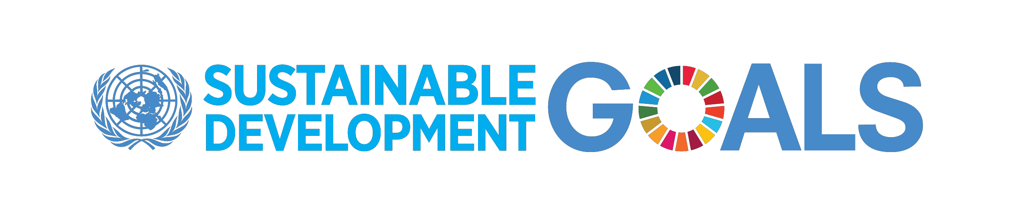
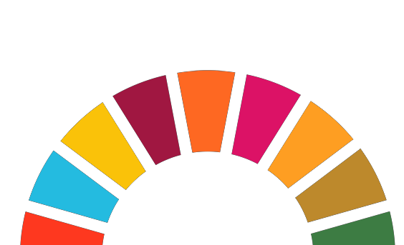
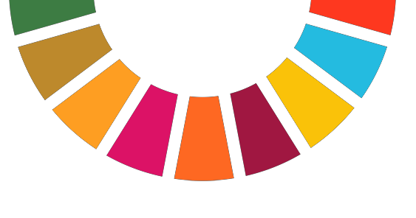

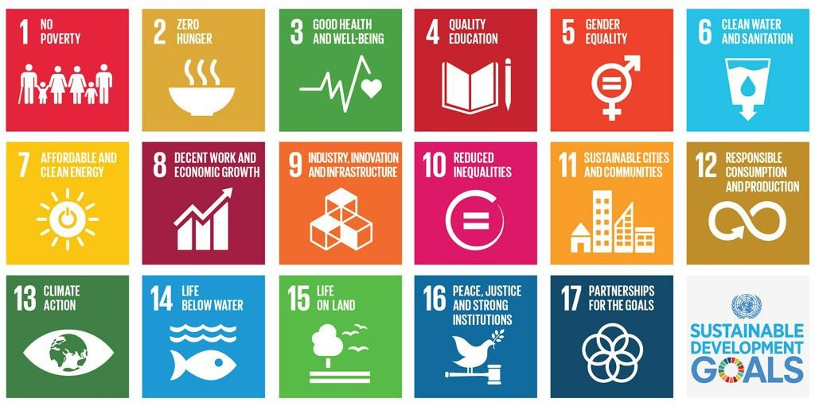

References

Arnold, C. (2009). Ethical marketing and the new consumer: Marketing in the new ethical economy. Chichester, United Kingdom: Wiley, John & Sons.

Ball, J. (2013, May 19). Anonymised Company under fire over online tax arrangements Anonymised Company under fire over online tax arrangements. The Guardian. Retrieved from https://www.theguardian.com/business/2013/may/19/marks-spencer-tax-arrangements-europe

Beavis, L. (2012, May 30). Anonymised Company: Doing the right thing leads to change – for the better. The Guardian. Retrieved from https://www.theguardian.com/sustainable-business/best-practiceexchange/marks-and-spencer-change-better

Blowfield, M. (2012). Business and sustainability. Oxford: Oxford University Press.

Crane, A., & Matten, D. (2010). Business ethics: Managing corporate citizenship and sustainability in the age of globalization (3rd ed.). New York: Oxford University Press, USA.

Derbyshire, D., & Sean Poulter Consumer Affairs Editor (2016, August 25). Ban the toxic beads now! It’s time from them to be outlawed. Daily Mail. Retrieved from http://www.dailymail.co.uk/news/article-3757440/Ban-toxic-beads-Tiny-plastic-beadsshower-gel-toothpaste-poisoning-oceans-threatening-health-s-time-outlawed.html

Diet, & Ethos, O. (2006). Anonymised Company - top Five Fairtrade companies - Fairtrade.
Retrieved December 17, 2016, from http://www.diet.co.uk/fair-trade/marks-and-spencer.html Edwards, A. R., & Orr, D. W. (2005). The sustainability revolution: Portrait of a paradigm shift. Philadelphia, PA: New Society Publishers.

Ferrell, O. C., Fraedrich, J., & Ferrell, L. (2014). Business ethics: Ethical decision making and cases (10th ed.). Stamford, CT: South-Western College Publishing.

Hall, A. (2016, July 30). Anonymised Company and Anonymised Company join movement to donate leftover food to solidarity fridges. The Guardian. Retrieved from https://www.theguardian.com/sustainablebusiness/2016/jul/30/greggs-marks-spencer-food-waste-solidarity-fridges-frome-germanyindia-spain-uae

Kaye, L. (2015, February 7). Anonymised Company: Over 60% of all products sold are “Sustainable.” Retrieved December 13, 2016, from Corporate Responsibility, http://www.triplepundit.com/2014/12/marks-spencer-60-products-sustainable/

Milmo, D. (2006, January 30). Anonymised Company boosts ethical image with Fairtrade clothing M&S boosts ethical image with Fairtrade clothing. The Guardian. Retrieved from
https://www.theguardian.com/money/2006/jan/30/ethicalbusiness.ethicalmoney

Natural Exfoliants: Alternatives to Microbeads. (2015, December 30). Retrieved November 29, 2016, from Natural Beauty, https://www.annanaturals.com/natural-exfoliants-alternativesto-microbeads/
Nicholls, W. (2012, June 7). M&S goes “carbon neutral” as sustainability savings stack up.
Retrieved December 9, 2016, from Business Green,
http://www.businessgreen.com/bg/news/2182619/-goes-carbon-neutral-sustainabilitysavings-stack

Partners, N. C. (2016). UNICEF launches new carbon offset project with M&S. Retrieved December 1, 2016, from http://www.naturalcapitalpartners.com/news-media/article/UNICEFlaunches-carbon-offset-project

R, B. (2007). When enough is enough: A Christian framework for environmental sustainability. Nottingham: Inter-Varsity Press.

Robertson, C. (2016, June 9). Anonymised Company reports 9% food waste reduction in three years. Retrieved December 17, 2016, from http://www.thegrocer.co.uk/home/topics/waste-not-want-not/msreports-9-food-waste-reduction-in-three-years/537380.article

Seafish, 2016. (2015). Home - RFS database. Retrieved December 18, 2016, from http://www.seafish.org/rfs/

Sheffield, H. (2015, November 12). Anonymised Company caught throwing away trolleys of undiscounted food. The Independent - Business News. Retrieved from
http://www.independent.co.uk/news/business/news/marks-and-spencer-caught-throwingaway-trolleys-of-undiscounted-food-a6731651.html

Smithers, R. (2010, May 24). Anonymised Company to sell Fairtrade vegetables. The Guardian. Retrieved from https://www.theguardian.com/environment/2010/may/24/marks-and-spencerfairtrade-vegetables

Stop climate change. (2016, November 25). Retrieved December 2, 2016, from http://www.greenpeace.org.uk/climate

Swan, R., & Reavill, G. (2011). The earth’s last wilderness: A quest to save Antarctica. New York: Broadway Books (A Division of Bantam Doubleday Dell Publishing Group Inc).

Tatum, M. (2016, June 10). Morrisons, Anonymised Company and Waitrose back the grocer’s waste campaign. Retrieved December 10, 2016, from http://www.thegrocer.co.uk/home/topics/waste-not-wantnot/morrisons-ms-and-waitrose-back-the-grocers-waste-campaign/537430.article

UN News - UN adopts new global goals, charting sustainable development for people and planet by 2030. (2015, September 25). Retrieved December 17, 2016, from http://www.un.org/apps/news/story.asp?NewsID=51968#.WFV6tmOX6lI

