Student name: Tung Dao
Institution: Nottingham Trent University

LITERATURE REIVEW OF
GREEN SUPPLIER SELECTION WITH INTEGRATING BETWEEN ANALYTICAL NETWORK HIERARCHY AND
GREY RELATIONAL ANALYSIS METHODOLOGIES

Supervisor: Lynn Oxborrow

TABLE OF CONTENTS

0. Abstract 2
1. Introduction 2
2. Green supplier management and selection 3
3. Analytical Network Hierarchy (ANP) 4
3.1. Advantages of the ANP Approach 4
3.2. Limitations of the ANP Approach 6
4. Grey Relational Analysis (GRA): 7
4.1. Advantages of the GRA 7
4.2. Limitations of GRA 8
5. Proposed approach, case study and recommendations 9
6. Conclusion and limitations 16
7. References 17
- Abstract
In general, this report aims to answer this research question “Which is the most appropriate approach for green supplier selection?” by the discussion of the following contents. Firstly, there will be a brief introduction about green supplier management and selection, and a critical analysis of the advantages and drawbacks of ANP and GRA. From that analysis and the literature, a proposed approach with integrating between those two methodologies will be discussed regarding its usage, benefits, and gained results applied to a case study. Finally, from the discussion of the case study, the report will provide some significantly recommendations for the purpose of more practical and efficient application in general and in Vietnam.
- Introduction
According to the findings of Beschorner and Muller, 2007, globalisation has pushed both governments and firms to consider the urgency of corporate social responsibility (CSR) because of our negative influences on the environment. As highlighted by Willard (2008), the amount of the wasting resources currently has been more than 10 times better than the amount of using them. For that reason, over recent decades, environmental issues have been more and more considered in supply chain management (Deans, 1999; Preuss, 2005; Lee et al 2009; Baskaran et al 2012). In particular, more firms have focused on developing environmentally friendly products and services for the sustainable development purpose. This view is supported by Igarashi et al (2013) who write that firms are likely to be motivated to design, produce and provide green products, and enhance the importance of the green procurement. It is undeniable to say that supplier selection plays a very essential in not only purchasing right materials, solutions or products at a competitive cost level, but also in improving its environmental performance throughout its supply chain.
In terms of the supplier selection, especially regarding the environmental issues, Jabbour and Jabbour (2009) indicate that the multiple environmental criteria pose significant challenges both for purchasers and suppliers. For that reason, Li et al (2007) state that there were several methods to solve the supplier selection problem, the main ones being the linear weighting methods (LW), analytic hierarchy process (AHP), analytic network process (ANP), and grey relational analysis (GRA). Although LW is simple to use, the factors are weighted equally and their evaluation heavily depends on decision maker’s judgment. Regarding AHP, despite the consideration of dependency within a cluster of criteria, this method does not take into account interdependencies among different clusters and uncertainties. Collectively, ANP (an extension of AHP) and GRA are the two most common and efficient approaches which significant support the supplier selection procedure (De Boer et al, 2001). For that reason, those approaches will be critically discussed in this report regarding the complex environmental considerations in green supplier selection.
Regarding the rationale of the report, Vietnam, the report author’s home country, has been a developing country and likely to be motivated to consider the corporate social responsibility for the internationalisation purpose. Similarly, Tencati (2010) highlights that the inability to meet social and environmental standards can be a negative the barrier to doing business in international markets. For that reason, this report can be a suggestion for Vietnamese suppliers or firms for applying the proposed approach for the green supplier selection procedure which complies to international environmental standards, such as ISO 14000, ISO 9000 and Total Quality Environmental Management. Those play essential role in the current business scenario in Vietnam with the increasing opening of the market such as World Trade Organization (WTO) and Trans-Pacific Partnership (TPP) (Forbes, 2016).
- Green supplier management and selection
According to the findings of Lee et al (2009) and Hsu and Hu (2009), green supplier management has been becoming more common both in recent business and literature reviews. As the result of the emphasis on environmental issues, increasingly more authors are indicating supplier selection procedure and criteria based on environmental aspects (Handfield et al, 2002; Humphrey et al, 2003; Sarkis, 2006; Lee et al, 2009; Bai and Sarkis, 2010; Hashemi et al, 2015; Rajesh and Ravi, 2015). Specifically, green supplier selection requires significant consideration of a great number of attributes regarding environmental factors. Figure 2.1 shows the most common environmental criteria referred to in the green supplier selection literature.
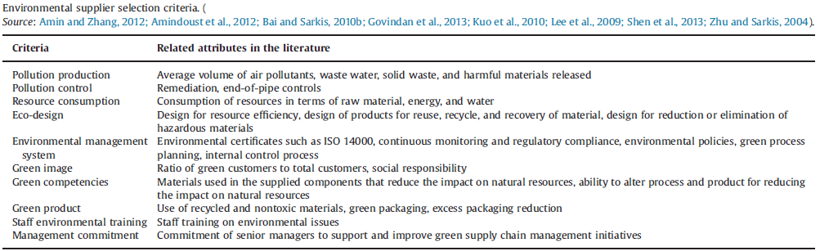
(Excerpt from Hashemi et al, 2015)
Figure 2.1: Environmental supplier selection criteria
Moreover, green supplier management, as highlighted by Srivastava (2007), involves the integrating environmental thinking throughout the supply chain with engagement of both the organisation and its suppliers. It should include product design, material sourcing and selection, manufacturing processes and delivery, and even the reverse logistics of the product after its useful life. In the same vein, from the view point of Narasimhan and Carter (1998), environmental supply chain management consists of the function of purchasing activities regarding the reduction, recycling, reuse and the substitution of materials. Collectively, from the findings of the above authors and the definitions of the criteria of Hashemi et al (2015) mentioned in Figure 2.1, the three most common environmental criteria, including pollution production, management commitment and resource consumption, will be discussed in the case study in this report.
- Analytical Network Hierarchy (ANP)
The ANP technique is composed of two phases, including the development of pairwise comparisons of criteria and the supermatrix evaluation, shown in Figure 3.1. In the first phase, there are pairwise comparisons of the elements to figure out their relative importance weights. Referencing to the findings of Sarkis (2003), this phase plays an important role not only in generating inputs for the next phase, but also in determining the network of interactions between the various selection criteria.
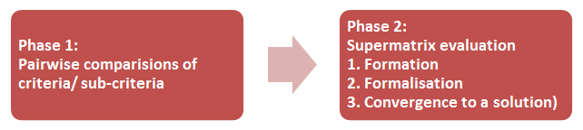
In the second phase, the supermatrix evaluation consists of three steps, the formation, the normalisation and convergence to a solution.

(Sarkis, 2003; Lee and Kim, 2000)
Figure 3.1: Two phases of ANP Approach
  - Advantages of the ANP Approach
Firstly, as highlighted by Sarkis (2003), ANP is a viable tool for supplier selection decisions regarding green supply chain management, especially the environmental business practices. Specifically, ANP is a robust tool in dealing with the complexity and dynamic characteristics of the environmental consideration which should be addressed not only in the product design, material sourcing and selection, manufacturing processes and delivery, but also in the reverse logistics of the product after its useful life.
In addition, the pairwise comparisons in the first phase of the ANP approach, as highlighted by Lee and Kim (2000), can deal with the problem of dependence among criteria or alternatives. This view is supported by Zhu and Dou (2010) who study the interdependence between environmental (including Pollution Control – PC, Pollution Prevention – PPE, Environmental Management System – EMS, Resource Consumption – RC and Pollution Production – PPO) and the performance evaluation (objective), shown in Figure 3.2.
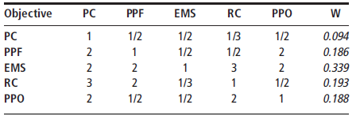
(Zhu and Dou, 2010)
Figure 3.2: Pairwise comparison matrix and relative importance weight
Moreover, according to the findings of Hashemi et al (2015) and Sarkis (2003), ANP can clearly indicate the relationships between environmental selection criteria and economic or conventional factors (such as cost, quality and technology) for the flexible use in practice. Those will be discussed further in the Proposed Approach part.
Finally, the final converged supermatrix in the phase 2 of the ANP method provides decision-makers with the decision framework with the relative priorities for each alternative. For instance, although Figure 3.4 shows that the supplier 1 (S1) has the highest overall performance, it is not the best choice for the decision-makers to achieve the objective of improving the environmental supply chain based on the data on Figure 3.3. For that reason, based on the supermatrix of the ANP approach, the decision-makers can decide to collaborate with suppliers which are the most appropriate to their different organisational strategies and resources.

(Zhu and Dou, 2010)
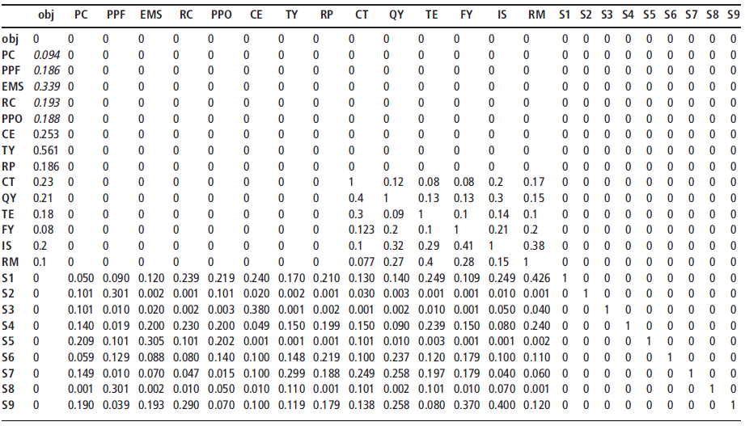
Figure 3.3: ANP supermatrix for nine suppliers’ overall performance measurement decision network
Environmental factors
Organizational factors
Strategic performance measures

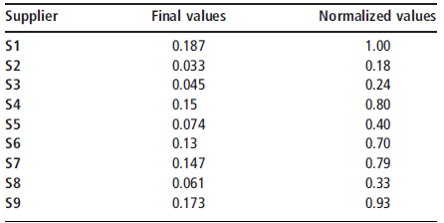
(Zhu and Dou, 2010)
Figure 3.4: The values of suppliers’ overall performance measurement
  - Limitations of the ANP Approach
According to the findings of Sarkis (2003), the major limitation of the ANP approach is the requirement of the large amount of decision-maker input. It is undeniable to say that there are many uncertainties of data in the supplier selection process; thus, the decision-makers need to deal with both complete and incomplete information. Especially in the green supplier selection, changes of environment can lead to significant adjustments of environmental policies and criteria to ensure the sustainable development. Moreover, another disadvantage is the remarkable complexity of this approach when the number of criteria and their relationship increase (Sarkis and Talluri, 2002). Collectively, Golmohammadi and Mellat-Parast (2012), and Wu (2002) suggest that GRA is one of the best approaches for supplier selection in the business environment which can deal with the limitations of the ANP. This will be discussed further in the next part.
- Grey Relational Analysis (GRA):
Based on the literature, Figure 4.1 shows the summary of the supplier selection based on the GRA approach which can solve the problem of uncertainties of the group decision-making

(Li et al, 2007, Rajesh and Ravi, 2015)
Figure 4.1: GRA approach procedure
  - Advantages of the GRA
Firstly, according to Hashemi et al. (2015), the GRA method can significantly support complex decision-making process by capturing, process, and even integrating uncertainties. In the same vein, Golmohammadi and Mellat-Parast (2012) indicate that because of the capability of handling complicated problems regarding both complete and incomplete information, the GRA becomes a superior method to traditional decision-making tools.
Besides, the capability of dealing with the complexity of the information leads to the flexible application of GRA (Fu et al, 2012). Especially, the GRA can provide satisfied outcomes with either a small or large amount of variability in the factors. This reason leads to GRA approach to clearly excess ANP approach in dealing with the increase of criteria in supplier selection. In the same vein, Baskaran et al (2012) note that a major advantage of the GRA is that it considers the fuzzy and flexible conditions of group decision-making circumstances regarding the inconsistent information. For that reason, from the step 1 shown in Figure 4.1, a committee of decision makers is formed to identify the attribute weights of suppliers and give the ratings of alternatives throughout the supplier selection process. This will be discussed further in the Proposed Approach part.
Moreover, GRA can significantly support the supplier selection with a multiple attribute decision-making problem because of the significant effects of various qualitative and quantitative factors. In particular, as identified by Baskaran et al (2012) and Zhang et al (2005), the representation of criteria in the GRA uses linguistic values from the beginning until the weigh estimation and the alternatives’ assessment. Whereas, the ANP or other fuzzy theories only apply the linguistic values first, then they are transformed into exact numerical values. It is undeniable to say that the decision-makers’ judgments are often uncertain so that cannot be estimated by an exact value.
This can be illustrated by the linguistic assessment and associated grey values shown in Figure 4.2. More specifically, in the Step 2 in the GRA method mentioned in Figure 4.1, the committee of decision makers rates the importance of attributes on linguistics scales to deal with the uncertainties, and those ratings will be converted into associated grey values for next steps.
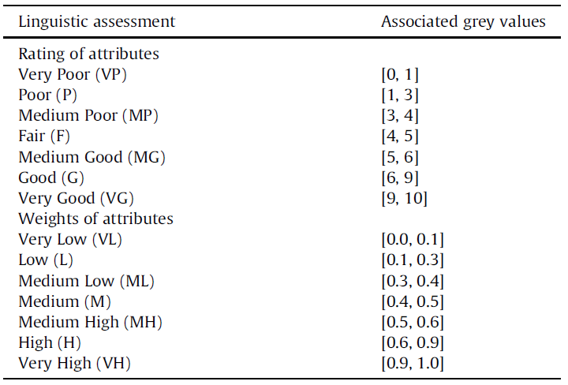
(Rajesh and Ravi, 2015)
Figure 4.2: Linguistic assessment and the associated grey values.
  - Limitations of GRA
Hashemi et al. (2015), this approach ignores the bias of possible judgment of decision-makers. In other words, there can be different opinions from different decision-makers for weighting criteria and the approach does not check any possible inconsistency.
Another drawback of the GRA is the lack of the consideration of the possible interdependencies among criteria (Golmohammadi and Mellat-Parast, 2012). Particularly, whereas the ANP applies the pairwise comparison matrix and the super matrix to indicate the interdependencies between criteria, the GRA only shows their internal independence and does not take into account their possible interdependencies.
Collectively, from the consideration of advantages and limitations of the ANP and GRA approach, there will be a proposed approach which addresses the integrating the two methods in the following part.
- Proposed approach, case study and recommendations
After figuring out the advantages and disadvantages of the ANP and GRA approach from previous research and referencing to the findings of Hashemi et al (2015), the report will propose an approach which is the result of integrating between those two methods to deal with the drawbacks of those approaches and increase the efficiency of their application. As identified by Hashemi et al. (2015), the integrated application of the ANP and GRA significantly supports the supplier selection by weighting and ranking the suppliers respectively. Particularly, the ANP addresses the interdependencies among the criteria, whereas, the GRA is used to deal with the uncertainties in supplier selection decisions. Besides, some more benefits will be critically indicated in details throughout this section with the discussion of the proposed approach with 5 steps (shown in Figure 4.3) and its application to a case of an automobile manufacturer in Iran – Sazeh Gostar Saipa Corporation. Moreover, recommendations for the use of the proposed approach also will be mentioned throughout the discussion of its steps.
Regarding to the case study, for the purpose of internationalisation, that firm targeted to gain a competitive advantage by improving their economic and environmental performance throughout its supply chain. In addition, the collaboration with foreign companies stimulated the implementation of Green Supply Chain management in the firm. For that reason, Hashemi et al (2015) studied the application the proposed approach integrating the ANP and GRA approach to the firm’s supplier selection procedure.

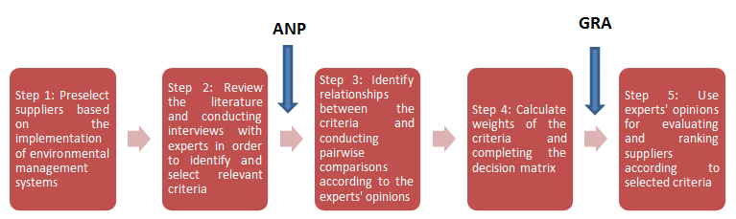
(Hashemi et al, 2015)
Figure 4.3: Proposed green supplier selection procedure

- Step 1 and Step 2: Preselect suppliers, and identify and select relevant criteria
The first two steps are to preselect suppliers and identify relevant selection criteria referencing to literature and the implementation of environmental management systems such as ISO 14000 series, ISO 9000, QS9000 or Total Quality Environmental Management (TQEM). Particularly, Sarkis (2003) suggests that the ISO 14000 certification and Total Quality Environmental Management (TQEM) should be considered being goals for the organisation and its suppliers. For example, the ISO 14000 standards provide a framework for firms to systematise and improve their environmental management efforts based on the Plan-Do-Check-Act Cycle. Thus, the goal of the continuous improvement can be set in operations not only within the firms and but also in their supplier selection. In the same vein, the IISD (2015) notes that the TQEM gives guidelines for organisations to focus on ensuring environmental quality and continuous improvement, and eliminating environmental risks by doing the job right first time.
Regarding the case study, Baskaran et al (2012) state that conventional criteria such as cost, quality and technology play a very essential role in the supplier evaluation. In addition, some studies indicate the remarkable relationships between green supply chain management, environmental and economic performance (Rao and Holt, 2005; Zhu and Sarkis, 2004; Lindgreen et al, 2009). For that reason and for the purpose of the practical application, Hashemi et al (2015) intend to indicate a comprehensive green supplier selection framework with the integrating both environmental and economic criteria in the case study. However, as identified by Saaty (1980) and also by Lee et al (2009), a cluster with more than seven factors often causes the confusion and difficulties for experts to make pairwise comparisons. For that reason, the case study focuses on the six most common sub-criteria (three from the environmental criterion and three from the economic criterion) and their interactions shown in Figure 4.4.
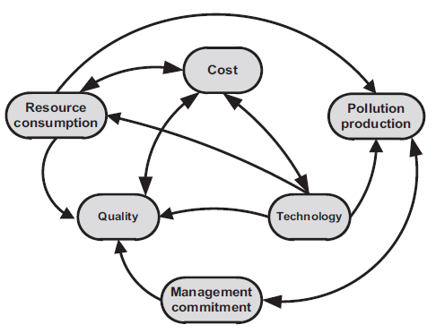
(Hashemi et al, 2015)
Figure 4.4: Network of interactions between the sub-criteria.
A committee of 4 experts, who were a logistics supervisor, the CEO, the health, safety and environmental supervisor, and the procurement manager, were interviewed and answered a structured questionnaire. As the result, they preselected 5 potential suppliers and listed six criteria for the green supplier selection referencing to the previous research, the ISO 14000 series and the firm’s scenario to select relevant criteria, including pollution production, resource consumption, management commitment, cost, quality and technology.
Besides, from the literature and especially from the findings of Lee et al (2009), the author of this report (the author) figured out that Lee et al (2009) proposed hierarchy and definitions of the criteria and sub-criteria of the green supplier selection, shown in Figure 4.5, can significantly support the decision-makers in the select relevant criteria for the green supplier selection. Again, the green supplier management, as highlighted by Srivastava (2007), involves the integrating environmental thinking throughout the supply chain with engagement of both the organisation and its suppliers. More specifically, it should include product design (mentioned in the C2 in Figure 4.5), material sourcing and selection (C1 and C6), manufacturing processes and delivery (C3, C4, and C5), and even the reverse logistics of the product after its useful life (C5 and C6). Similarly, from the view point of Narasimhan and Carter (1998), environmental supply chain management consists of the function of purchasing activities regarding the reduction, recycling, reuse and the substitution of materials; those are significantly addressed in Figure 4.5 in C2, C3, C4, C5 and C6.
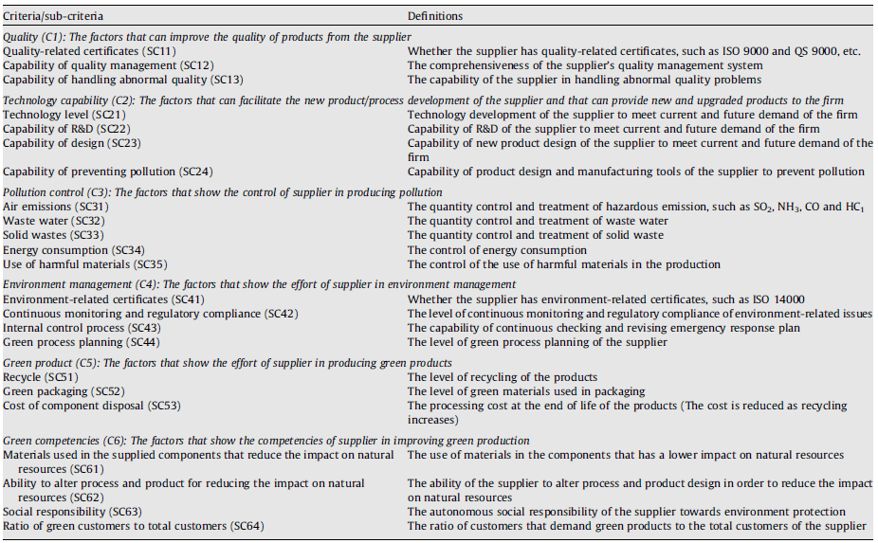
(Lee et al, 2009)
Figure 4.5: Hierarchy and definitions of the criteria and sub-criteria of
the green supplier selection

From the recommended criteria, a firm can require its suppliers to provide their data relating to the environmental issues or those can be found in their annual reports or Social Corporate Responsibility (SCR) reports. Figure 4.6 is the excerpt from the Annual Report of GlaxoSmithKline (GSK) which shows its energy and water use, gas emissions and waste amount in 2015. Those numbers play essential roles in the preselecting supplier step.
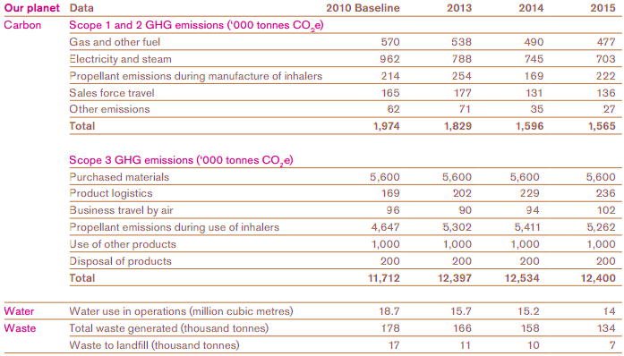
(uk.GSK.com)
Figure 4.6: GSK’s annual report 2015

Moreover, the experts can rely on environmental standards of supply chain consortia such as NEUPC, TUCO, CPC or the SEDEX (the largest collaborative platform for sharing sustainable supply chain data in the world) for the reference of the first step. For example, SEDEX indicate the implication of the green supply chain management in suppliers regarding their law-abiding and referencing to International Principles and Standards, including ISO 14001, United Nations Framework Convention on Climate Change, UN Convention on Biological Diversity and UN Agenda 21 for Sustainable Development (SEDEX, 2016). For that reason, the experts can select the name of recommended suppliers from SEDEX for further evaluation.
- Step 3 and Step 4: Conduct pairwise comparisons and construct interdependence matrix
Those steps were built mainly based on the advantage of the pairwise comparisons of the ANP approach to identify the relationships between the criteria. In terms of the case study, the experts were interviewed to recommend any possible interdependence between selected criteria and the results are shown in the Figure 4.7.

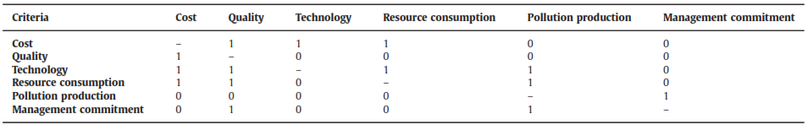
(Hashemi et al, 2015)
Figure 4.7: Relation matrix of criteria interrelationships.

After that, there were calculations of weights of the criteria by applying a super-matrix which is also essential part of the ANP. As the result, the researchers found that the final relative weights of cost, quality, technology, resource consumption, pollution production and management commitment are 0.357, 0.157, 0.260, 0.128, 0.049 and 0.049 respectively, shown in Figure 4.8.
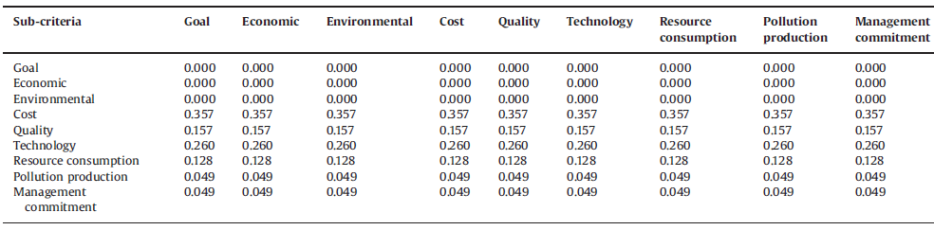
(Hashemi et al, 2015)
Figure 4.8: Super-matrix

Together, instead of only applying the GRA, the step 3 and 4 in the proposed approach can help decision-makers deal with the flexibility of criteria in practice and the problem of dependence among criteria or alternatives. Because GRA only indicates their internal independence and does not take into account their possible interdependencies.
- Step 5: Use experts' opinions for evaluating and ranking suppliers according to selected criteria
Because of the various uncertainties in the evaluating and ranking suppliers in practice, the proposed approach uses the GRA approach in this step to handle both complicated completed and incomplete information. Moreover, another reason of the use of the GRA method instead of the ANP approach in this step is the uncertainties of decision-makers’ judgments which cannot be estimated by exact numerical values. Particularly, the GRA can deal with both quantitative and qualitative factors by its use of the linguistic values. Figure 4.9 shows the evaluation in linguistic values of the performance of suppliers based upon the experience and judgment of the 4 experts in the case study. Then those linguistic values were converted to the associated grey values mentioned in Figure 4.2.
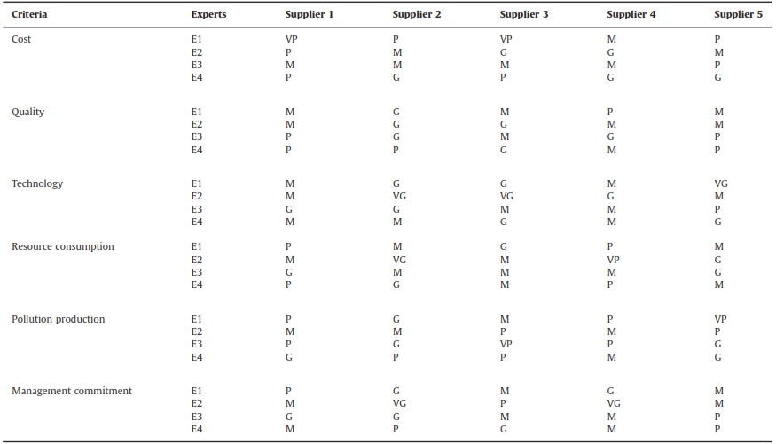
(Hashemi et al, 2015)
Figure 4.9: Linguistics assessment of the suppliers by experts

In addition, the application of the GRA approach to the proposed approach is to take the benefits from the group decision-making by raising the ideas and respecting to the judgment of different experts, shown in Figure 4.9. Figure 4.10 indicates the ranking of the 5 potential suppliers in the associated grey values.
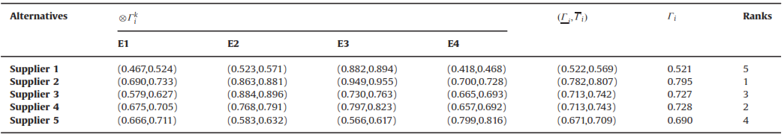
(Hashemi et al, 2015)
Figure 4.10: Suppliers’ Grey relational degree for each expert

Regarding the practical application of the proposed approach, after the step 5, users or decision makers can consider different scenarios of the green supplier selection based on the objectives and resources of the firm. More specifically, experts can rank suppliers with the economic criteria only and the environmental criteria only. Then, there should be comparisons between the ranking results of those scenarios and the initial condition to have a various views regarding different objectives of the business. Furthermore, for the purpose of more accurate evaluation outcomes, relative weight can be a useful addition to the committee of experts. For example, the relative weight for the procurement manager and environmental supervisor can be higher than those of other experts because of significant role in purchasing decision regarding the environmental issues.
- Conclusion and limitations
Overall, the proposed approach with the integrating between ANP and GRA method can significantly solve the problems of uncertainties by using linguistic values, and indicate the possible interdependencies between supplier green selection criteria through the pairwise comparisons and the super matrix. Because of the above benefits, the suggested approach can be applied to any firms, even in Vietnam which is a poor and incomplete information environment. Besides, the approach’s complying with international environmental standards (such as ISO 14000 and 9000 series, TQEM and UN regulations) can help firms improve their environmental performance in the green supplier selection procedure for the globalisation or internalisation purposes. Regarding the recommendation for better results as mentioned in the previous part, besides international environmental standards, firms can receive useful advice and suggestion about potential suppliers from consortia regarding the related industry such as CPC, NEUPC, TUCO (for universities) and SEDEX – a very helpful supply chain information platform.
Despite the advantages of the proposed approach, there are some limitations that should be addressed in its implementation. Particularly, the approach use is not simple because the uncertainties of the data and the interdependence considerations of criteria require complicated matrix and calculations. Furthermore, another drawback of the approach is the bias judgement of experts. To solve this problem, firms should add different weights for each expert based on his or her and influence of their judgment on the decision making in the supplier selection to improve environmental performance, for example, the highest weight for environmental experts. In addition, in order to see various views of the business and the differences between different organisational strategies, experts should consider different scenarios with and without one or some clusters of criteria. Finally, for the purpose of continuous improvement, firms should apply the Deming’s Cycle (Plan-Do-Check-Act) to make sure the green supplier selection match not only its resources, but also the current international standards and market’s requirements.

- References
Bai, C., Sarkis,J., 2010b. Integrating sustainability into supplier selection with Grey system and rough set methodologies. Int. J. Prod. Econ. 124, 252–264.
Bai, C., Sarkis,J.,2010a. Green supplier development: analytical evaluation using rough set theory. J.Clean.Prod. 18,1200–1210.
Baskaran, V., Nachiappan, S., Rahman, S., 2012. Indian textile suppliers’ sustainability evaluation using the Grey approach. Int. J. Prod. Econ. 135, 647–658.
Beschorner, T., Muller, M., 2007. Social Standards: Toward an Active Ethical Involvement of Businesses in Developing Countries. journal of Business Ethics. 73(1), 11-20
Davis, B., 2016. Vietnam To Approve TPP Trade Deal, But It May All Be For Nothing. Forbes [online]. Available at http://www.forbes.com/sites/davisbrett/2016/06/20/vietnam-to-approve-tpp-trade-deal-but-it-may-all-be-for-nothing/#5b7d6f3572bb [Accessed 03/09/2016].
De Boer, L., Labro, E., Morlacchi, P., 2001. A review of methods supporting supplier selection. European Journal of Purchasing and Supply Chain Management. 7(2), 75-89.
Deans, I., 1999. An approach to the environmental management of purchasing in the utilities sector. Eco – Management and Auditing. 6(1), 11-17.
Fu, X., Zhu, Q.,S arkis, J.,2012.Evaluating green supplier development programs at a telecommunications systems provider.Int.J.Prod.Econ.140,357–367.
Golmohammadi, D.,Mellat-Parast,M.,2012.Developing a Grey-based decision- making model for supplier selection. Int. J. Prod. Econ. 137,191–200.
Handfield, R., Walton, S.V., Sroufe, R., Melnyk, S.A., 2002. Applying environmental criteria to supplier assessment: a study in the application of the Analytical hierarchy process. European Journal of operational research. 141(1), 70-87.
Hashemi, S.,H., Karimi, A., Tavana M., 2015. An integrated green supplier selection approach with analytic network process and improved Grey relational analysis. Int. J. Production Economics, 159, 178-191.
Hsu, C.W., Hu, A.H., 2009. Applying hazardous substance management to supplier selection using analytic network process. Journal of Clearer Production. 17 (2), 255-264.
Humphrey, P.K., Wong, Y.K, Chan, F.T.S., 2003. Integrating environmental criteria into the supplier selection process. Journal of Materials Processing Technology. 138 (1-3), 349-356.
Igarashi, M., DE Boer, L., Fet, A.M., 2013. What is required for greener supplier selection? A literature review and conceptia; model development. Journal of Purchasing and Supply Management. 19(4), 247-263.
IISD – International Institute for Sustainable Development, 2016. Total Quality Environmental Management. Available at https://www.iisd.org/business/tools/systems_tqem.aspx [Accessed 25/07/2016]
Lee, A.H.I, Kang, H.Y. and Hsu, C.F., 2009. A green supplier selection model for high-tech industry. Expert systerms with application. 36 (4), 307-318.
Lee, J.W., Kim, S.H.,2000. Using analytic network process and goal programming for interdependent information system project selection. Computers and Operations Research. 27, 367-382.
Li, G.D., Yamaguchi, D., Nagai, M., 2007. A grey-based decision-making approach to the supplier selection problem. Mathematical and Computer Modelling. 46, 573-581.
Lindgreen, A., Swaen, V., Campbell, T.T., 2009. Corporate social responsibility practices in developing and transitional countries. Journal of Business Ethics. 90, 429-440.
Narasimhan, R., Carter, J.R., 1998. Environmental Supply Chain Management. The Centre for Advanced Purchasing Studies, Arizona State university, Tempe. AZ, USA.
Preuss, L., 2005. Rhetoric and reality of corporate greening: a view from the supply chain management function. Business Strategy and the Environment. 14 (2), 123-139.
Rajesh, R., Ravi, V. 2015. Supplier selection in resilient supply chains: a grey relational analysis approach. Journal of Cleaner Production. 86, 343-359.
Rao, P., Holt, D., 2005. Do green supply chains lead to competitiveness and economic performance. International Journal of Operations and Production Management . 25(9), 898-916.
Saaty, T.L., 1980. The analytic hierarchy process. McGraw-Hill, New York.
Sarkis, J., 2003. A strategic decision frame work for green supply chain management. Journal of Cleaner Production. 11, 397-409.
Sarkis, J., 2006. Greening the Supply Chain. Springer, Berlin.
Sarkis, J., Talluri, S, 2002. A model for strategic supplier selection. Journal of Supply Chain Management. 38 (1), 18-28.
SEDEX, 2016. SEDEX Supplier Workbook. Available at http://www.sedexglobal.com/wp-content/uploads/2013/04/Sedex-Supplier-Workbook.pdf [Accessed 20/08/2016]
Srivastava, S.K., 2007. Green supply chain management: a state of the art literature review. International Journal of Management Reviews. 9(1). 53-80.
Willard, B., 2008. The sustainability advantage. British Columbia: New Society Publishers.
Wu, H.-H.,2002. A comparative study of using Grey relational analysis in multiple attribute decision making problems. Qual. Eng. 15, 209–217.
Zhang, J., Wu, D.,Olson,D.L.,2005.ThemethodofGreyrelatedanalysistomultiple attribute decision making problems with interval numbers. Math. Comput. Model. 42,991–998.
Zhu, Q., and Dou, Y., 2010. A portfolio-based analysis for green supplier management using the analytical network process. Supply Chain Management: An International Journal. 15(4), 306-319.
Zhu, Q., Sarkis, J., 2004. Relationships between operational practices and performance among early adopters of green supply chain management practices in Chinese manufacturing enterprises. Journal Operations Management. 22(3), 265-328.

